

**WORKFROCE ADMINISTRATION SOLUTION (DEV)**

**College: SKP ENGINEERING COLLEGE**

**College Code:** 5122

|  |  |
| --- | --- |
| **Team Members** | **NM ID** |
| **Karthika S** | ECE2AD9ABFEE21DB5264750A81DF01DA |
| **Kubendiran S** | 41C56974DF072C7A2694A48932B8ED52 |
| **Malavika S** | B48AC589CEBB82E94EF4EF7ABF43C42D |
| **Manisarathi A** | 7BA49BE41B83E5F906D46608492AD707 |

**GitHub Repo** [**https://github.com/Manisarathia/Workforce-Administration-Solution-Dev-.git**](https://github.com/Manisarathia/Workforce-Administration-Solution-Dev-.git)

**Demo Video link**: https://youtu.be/xb_oPgX8awI

**1. User Story:**

In an effort to enhance data security and performance while simplifying system administration, TheSmartBridge company is transitioning to Salesforce, a new cloud technology. By leveraging this advanced platform, the company can ensure the safe storage of sensitive data through robust encryption and proactive backup mechanisms. The cloud's automated data replication capabilities provide added protection and efficient disaster recovery solutions. With access to scalable resources, TheSmartBridge can optimize performance, ensuring fast and reliable access to data.

**2. Project Overview :**

Workforce Administration Solution is a software application or platform designed to streamline and automate various aspects of employee’s working on projects and Asset Assignment processes within an organization. It serves as a centralized system for managing employee data, number of projects an employee is working on, tracking employee performance, and keeping record for the assets which they are assigned to.

**Project Flow:**

Milestone 1 : Creating Developer Account

Milestone 2 : Object

Milestone 3 : Tabs

Milestone 4 : The Lightning App

Milestone 5 : Fields

Milestone 6 : Setting OWD

Milestone 7 : User Adoption

Milestone 8 : Import Data

Milestone 9 : Profiles

Milestone 10 : Role

Milestone 11 : Users

Milestone 12 : Page layouts

Milestone 13 : Chatter group

Milestone 14 : Record types

Milestone 15 : Permission sets

Milestone 16 : Reports

Milestone 17: Dashboards

Milestone 18:Approval Process

Milestone 19: Apex Trigger

**Milestone 1-Creating Developer Account:**

**Activity 1:**

**Creating Developer Account:** Creating a developer org in salesforce.

1. Go to https: //developer.salesforce.com/signup

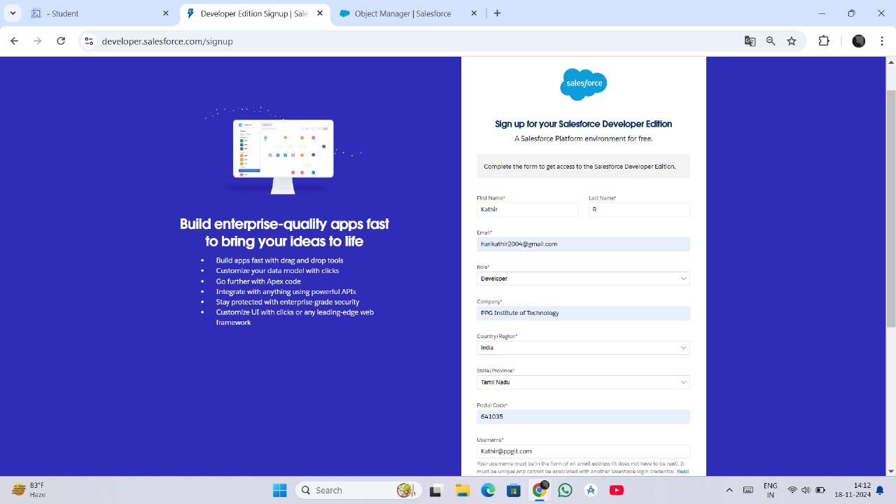

**Activity 2: Account Activation:**

After signing up, I activated my Salesforce Developer Account by verifying my email. I clicked on the "Verify Account" link, set a secure password, and answered a security question. Upon completing these steps, I was redirected to the Salesforce setup page, successfully enabling access to the platform’s features.

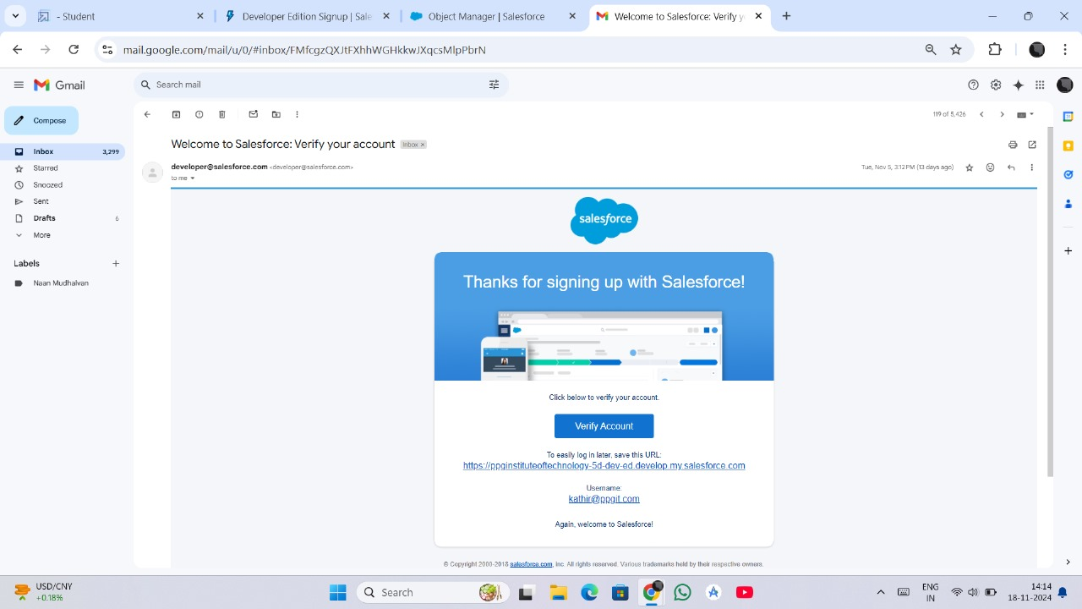

**Milestone 2: Object**

In the **Workforce Administration Solution (Dev)** project, creating objects is a crucial step to structure and manage data effectively. Objects in Salesforce serve as the foundation for storing and organizing records related to various workforce components. This phase involves creating several custom objects to facilitate workforce and project management, ensuring streamlined operations.

**Activity 1: Create Employee Object**

The **Employee** object is designed to store details about the workforce, including attributes such as employee name, designation, department, and contact information. This object serves as a central repository for managing all employee-related data, enabling efficient workforce tracking and administration.

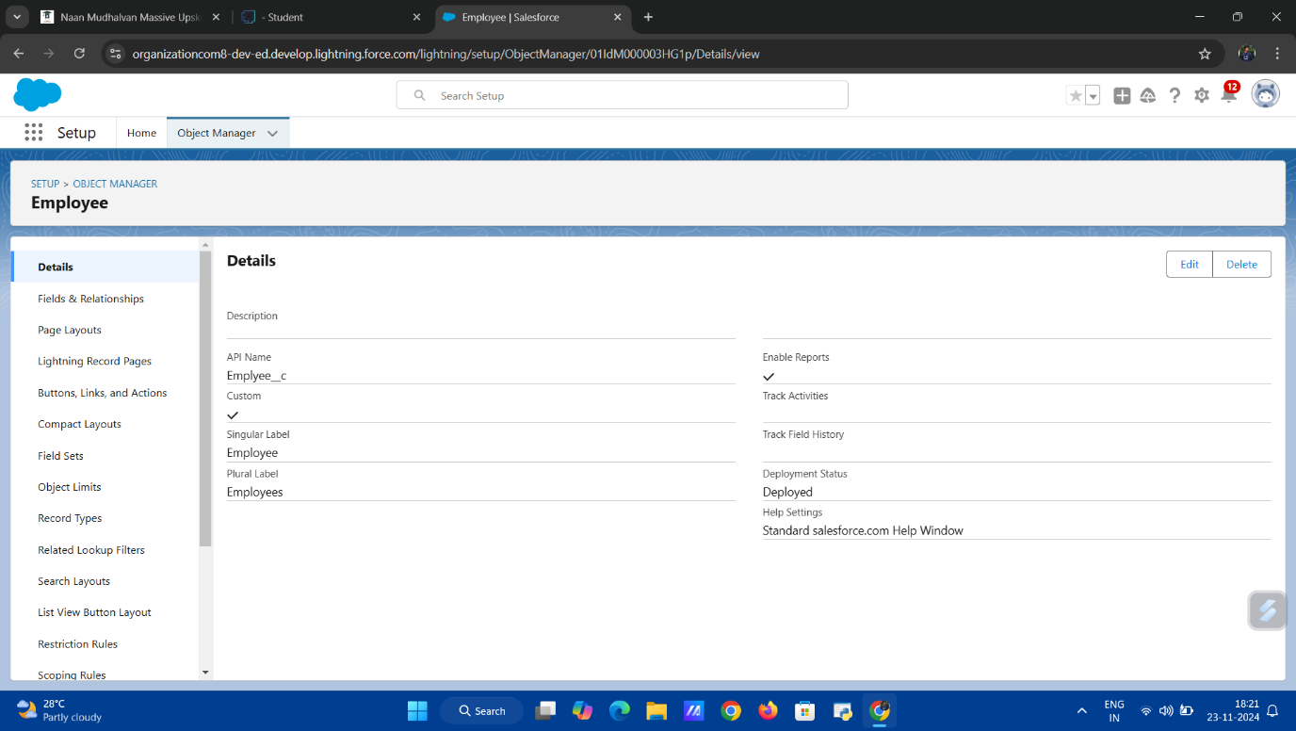

**Activity 2: Create Project Object**

The **Project** object is created to manage information related to workforce assignments and ongoing tasks. It includes fields such as project name, description, start and end dates, and the associated team. This object helps track and oversee projects, ensuring timely execution and completion.

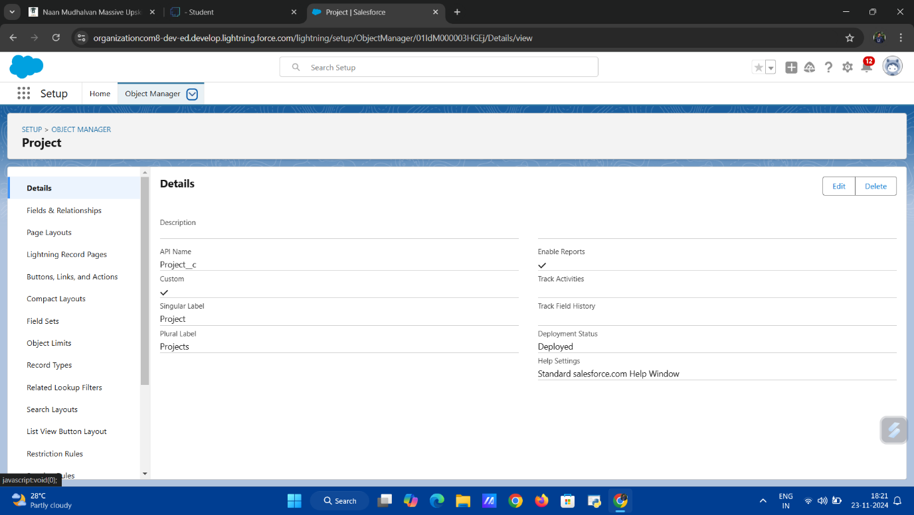

**Activity 3: Create Additional Objects**

Three additional objects are created to expand the functionality of the solution:

1. **ProjectTask**: This object manages individual tasks within projects, including task descriptions, status, deadlines, and assigned employees. It enhances task tracking and delegation.

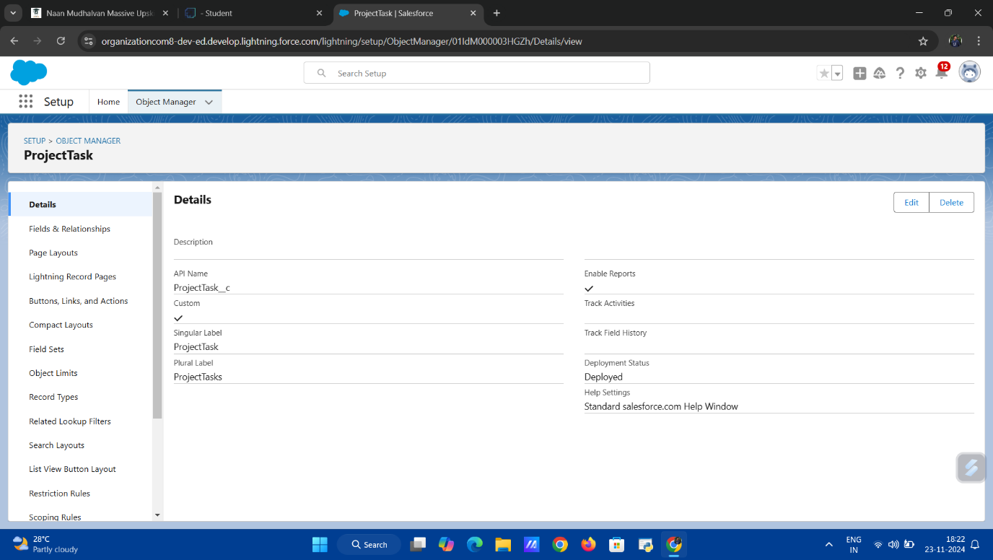

1. **Asset**: The Asset object stores information about resources and tools used in the workforce, such as equipment details, ownership, and availability status.

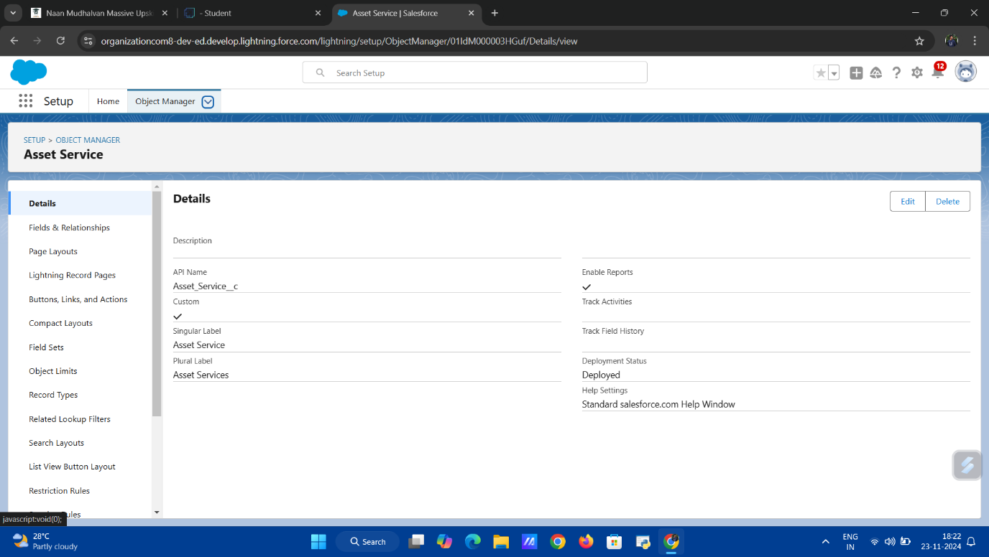

1. **Asset Service**: This object tracks the maintenance and servicing of assets, recording service dates, issues addressed, and service providers, ensuring optimal resource management.

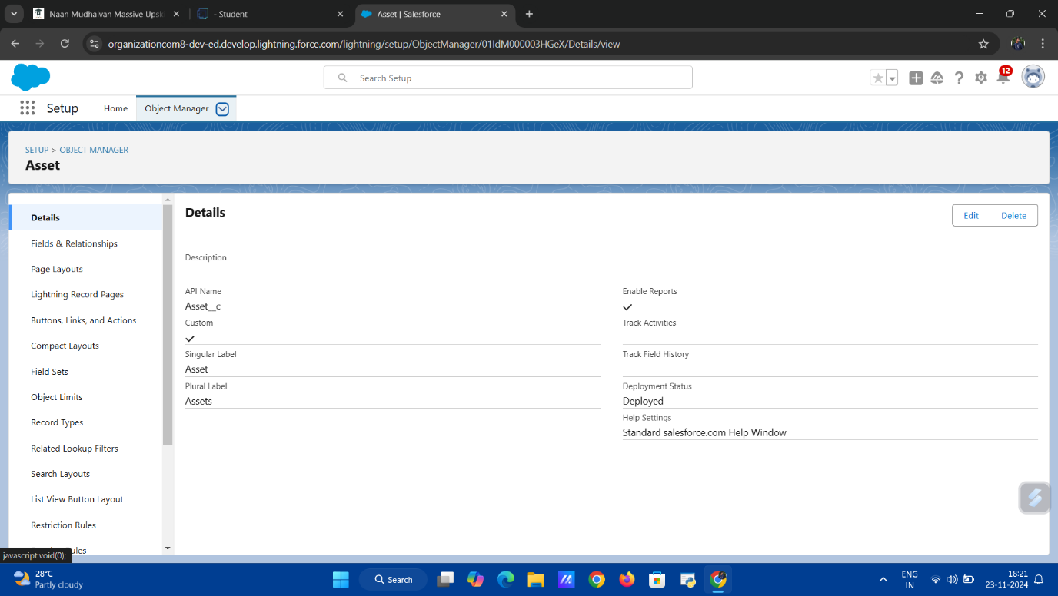

**Milestone 3 : Tab**

In the Workforce Administration Solution (Dev) project, creating tabs for custom objects is essential to provide an intuitive and user-friendly interface for accessing and managing data. Tabs in Salesforce allow users to interact directly with object records, enabling seamless navigation and efficient data management. This phase focuses on creating tabs for the primary objects in the solution.

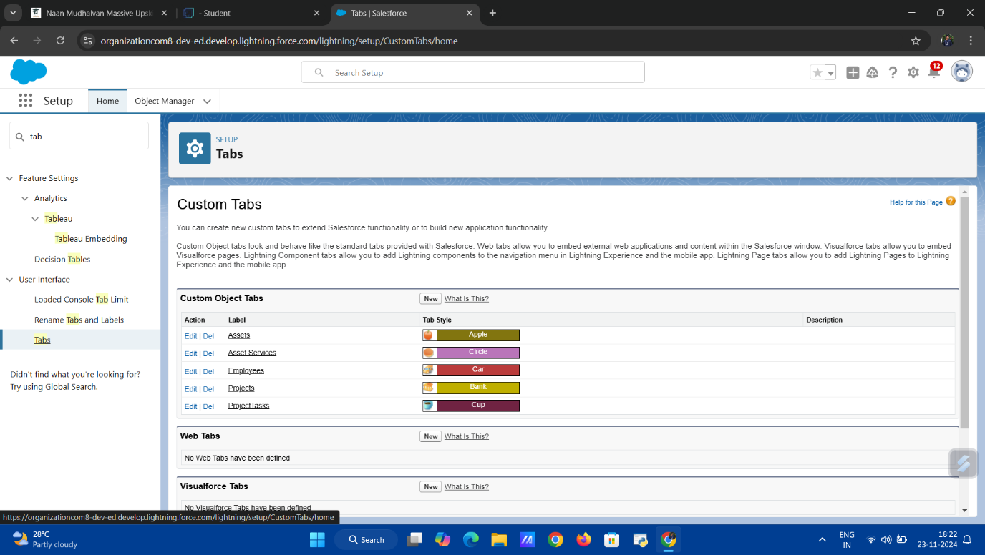

**Activity 1: Creating a Custom Tab for Employee**

A custom tab is created for the Employee object to allow easy access to employee records. This tab provides a user interface to view, create, and manage employee details such as names, roles, and contact information. Adding the Employee tab ensures that workforce-related data is easily accessible.

**Activity 2: Creating a Custom Tab for Project**

The Project object receives its own custom tab, enabling users to manage project records effectively. This tab facilitates the creation, tracking, and management of project details, including timelines, teams, and associated tasks. The Project tab serves as a hub for project-related activities.

**Activity 3: Creating Tabs for Remaining Objects**

**Custom tabs are also created for the remaining objects—ProjectTask, Asset, and Asset Service. These tabs ensure seamless access to specific datasets:**

* ProjectTask Tab: Enables tracking and managing individual project tasks.
* Asset Tab: Provides a user interface for monitoring organizational resources.
* Asset Service Tab: Offers quick access to records of asset maintenance and service activities.

**Milestone 4: The Lightning App**

In the **Workforce Administration Solution (Dev)** project, a **Lightning App** serves as a customizable workspace that integrates various components, such as objects, tabs, and utilities, into a unified interface. This app provides an intuitive and streamlined environment for users to manage workforce-related data and operations effectively.

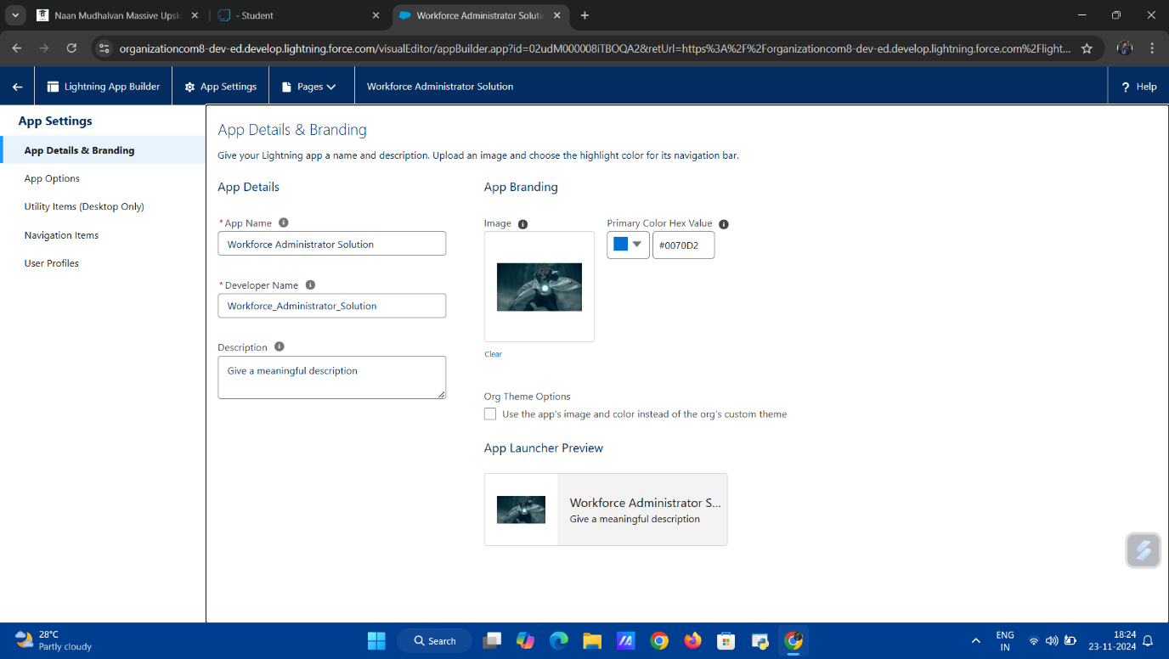**Activity 1: Create a Lightning App**

The creation of a **Lightning App** involves setting up a user-friendly application tailored to the needs of the project. The app is designed to centralize access to custom objects like **Employee**, **Project**, **ProjectTask**, **Asset**, and **Asset Service**, along with their respective tabs.

Key features of the app include:

* **Custom Branding**: Personalized app name, icon, and color scheme for enhanced usability.
* **Tabbed Navigation**: Organized layout for easy access to data and functionalities.
* **Utilities Integration**: Tools like Notes, Files, and Recent Items for improved productivity.

**Milestone 5: Fields & Relationships**

In the **Workforce Administration Solution (Dev)** project, **Fields & Relationships** play a pivotal role in defining the structure and behavior of data within the **Employee** object. This phase involves creating custom fields and relationships to ensure efficient data organization, enhance functionality, and establish meaningful connections between objects.

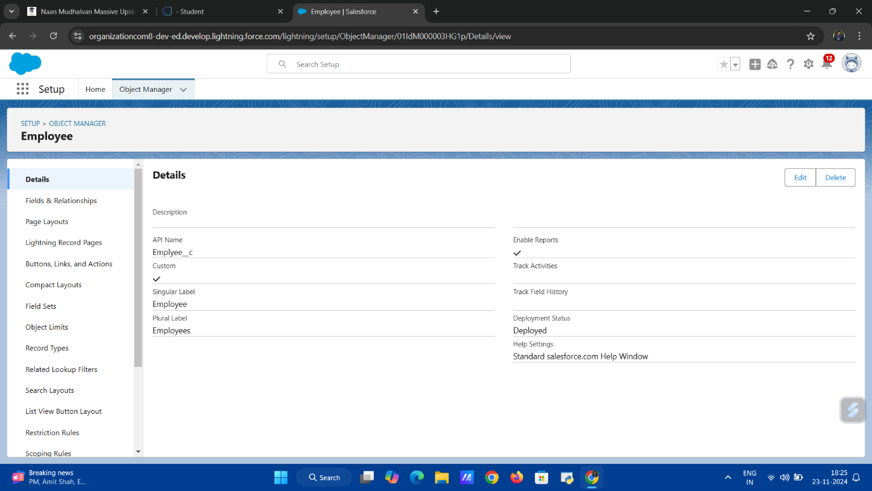

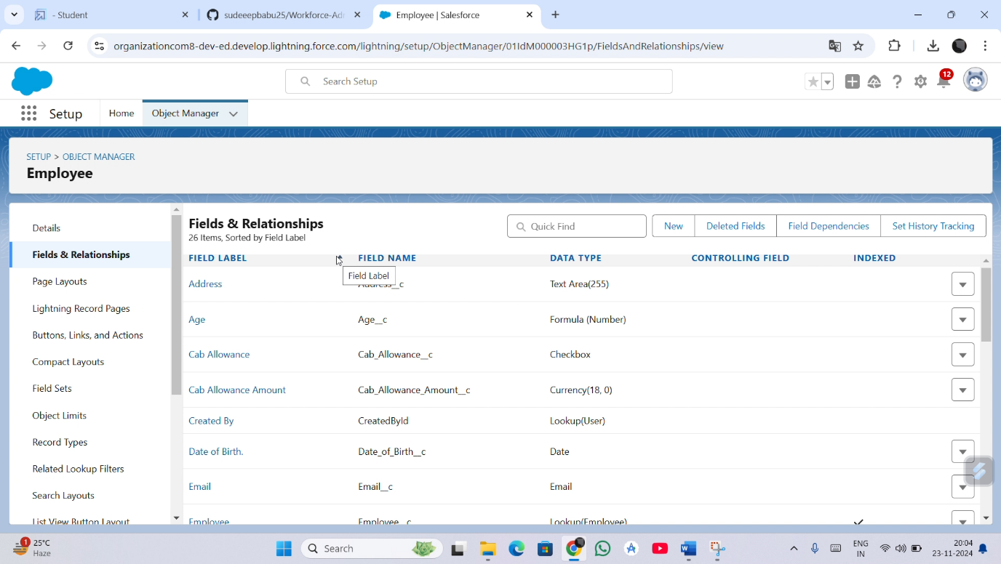

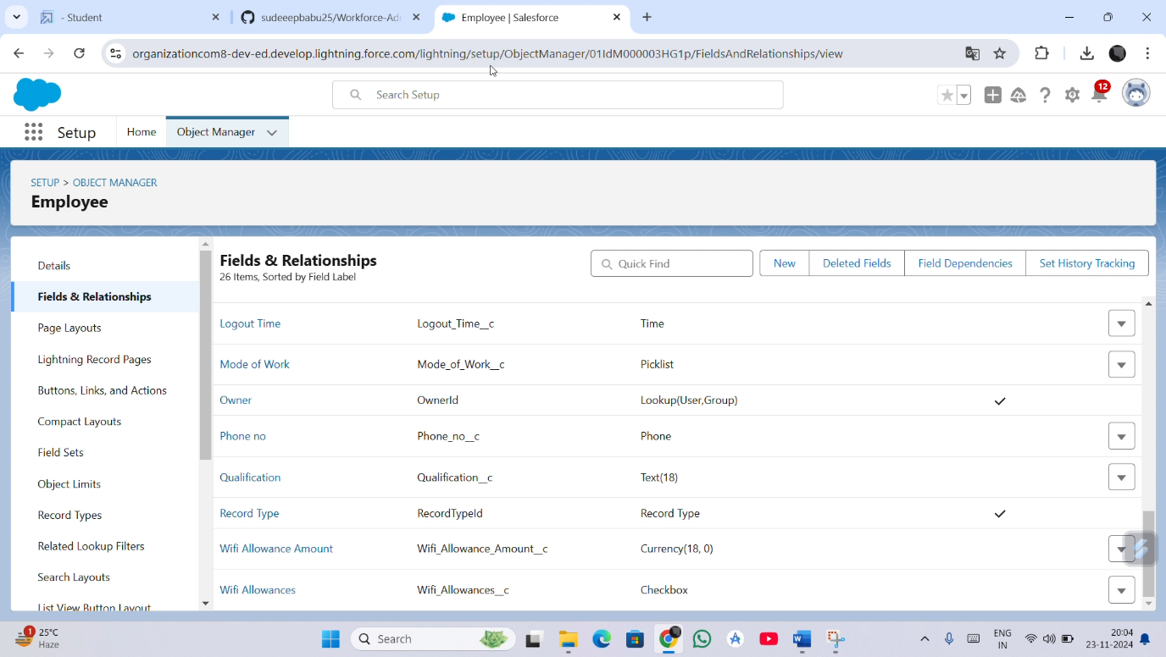**Activity 1: Creating a Text Field in Employee Object**

A **Text Field** is added to the **Employee** object to store essential textual data, such as employee names, identification numbers, or addresses. This field allows the entry of flexible and descriptive information.

**Activity 2: Creating Date of Birth Field in Employee Object**The **Date of Birth** field is created using the **Date** data type. This field captures employees' birthdates, enabling features like age calculations and eligibility verifications.

**Activity 3: Creating Formula Field in Employee Object**

A **Formula Field** is added to derive calculated values dynamically. For example, it can be used to calculate an employee’s age based on their **Date of Birth** field, improving automation and reducing manual input.

**Activity 4: Creating Picklist Field in Employee Object**

A **Picklist Field** is created to provide predefined options for data entry, such as job roles (e.g., Manager, Developer, Tester). This ensures consistency in data input and simplifies reporting.

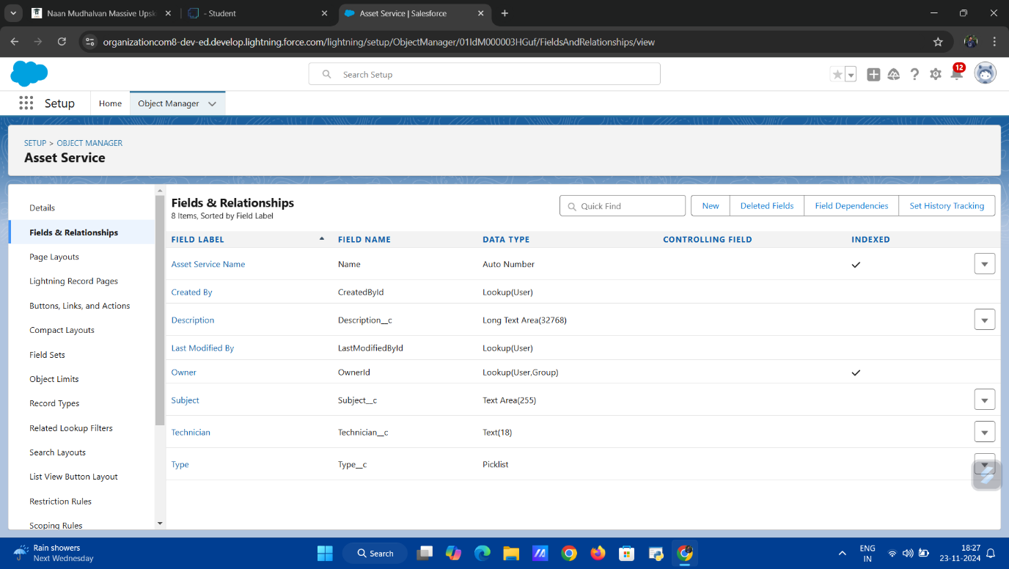

**Activity 5: Creating Self-Relationship Field in Employee Object**

A **Self-Relationship Field** establishes a relationship within the **Employee** object. For instance, it can represent reporting structures by linking an employee record to their manager's record, enabling hierarchical views.

**Activity 6: Creating Master-Detail Relationship between Employee & Asset Object**

A **Master-Detail Relationship** is established between the **Employee** and **Asset** objects. This links employees to the assets they manage or use, ensuring proper tracking and accountability.

**Activity 7: Creating Remaining Fields in Employee Object**

Additional fields, such as **Phone Number**, **Email**, and **Joining Date**, are created to capture comprehensive employee data. These fields enrich the dataset and support diverse operational needs.

**Milestone 6: Setting OWD (Organization-Wide Defaults)**

In the **Workforce Administration Solution (Dev)** project, configuring **Organization-Wide Defaults (OWD)** is critical for defining the baseline access level for records in Salesforce. OWD settings ensure data security by specifying whether records are accessible to all users or restricted based on roles and sharing settings. This phase focuses on setting up OWD for the solution's objects.

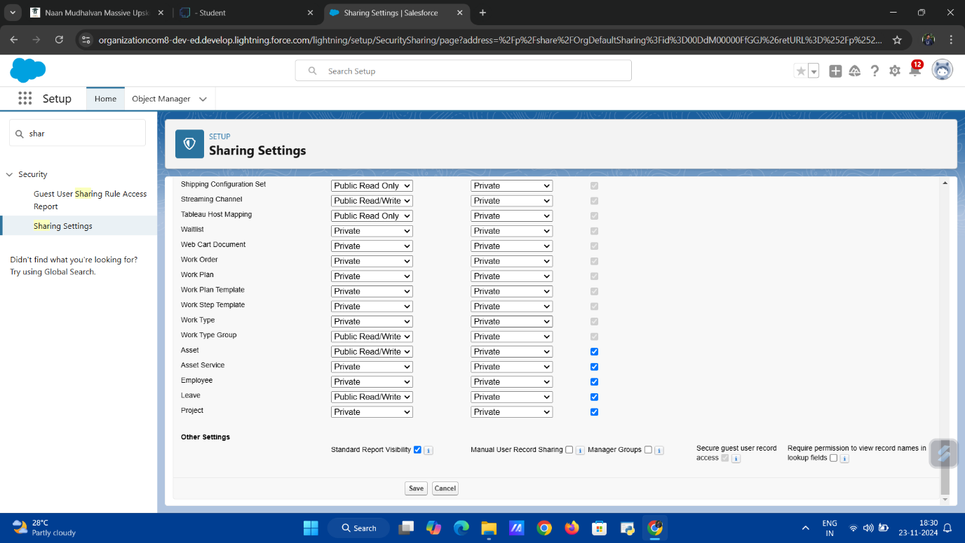

**Activity 1: Create OWD Setting**

The **Organization-Wide Default (OWD)** settings are configured to determine the default access level for all records in the organization. By default, objects such as **Employee**, **Project**, and **Asset Service** are configured with appropriate sharing rules to align with organizational requirements.

**Activity 2: Set OWD as Private for Project and Asset Service Object**

The OWD for the **Project** and **Asset Service** objects is set to **Private**. This ensures that only the record owners and users explicitly granted access can view or edit these records. The private setting enhances security by restricting access to sensitive project details and service records to authorized personnel only.

**Milestone 7: User Adoption**

In the **Workforce Administration Solution (Dev)** project, ensuring effective **User Adoption** is essential for the successful implementation of the system. It involves familiarizing users with the functionality of Salesforce and enabling them to perform basic operations such as creating, viewing, and managing records. This phase focuses on building user confidence and promoting efficient usage of the platform.

**Activity 1: Create a Record (Employee)**

Users are trained to create a new record in the **Employee** object. This includes entering key details such as name, contact information, job role, and other relevant fields. The activity demonstrates how to add new employees to the system effectively.

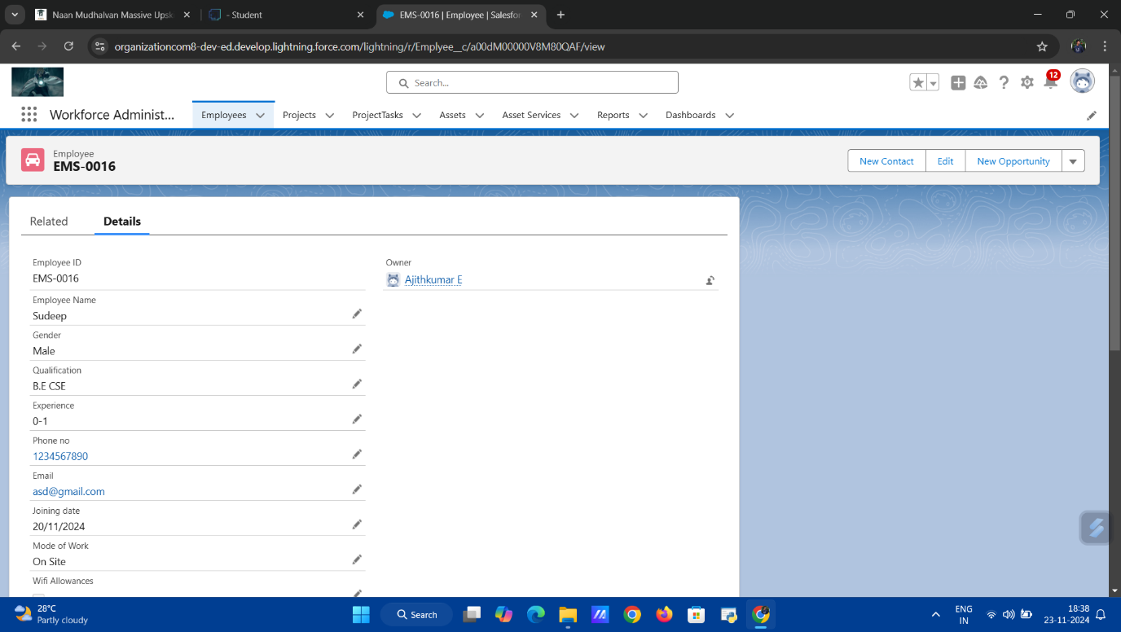

**Activity 2: View a Record (Employee)**

Users learn to view an existing record in the **Employee** object. This activity showcases how to access employee information, review details, and navigate related data, helping users understand data retrieval and record structure.

**Activity 3: Delete a Record (Employee)**

The final activity involves deleting an **Employee** record. Users are guided through the process of identifying records no longer needed and safely removing them, ensuring the system remains clean and up to date.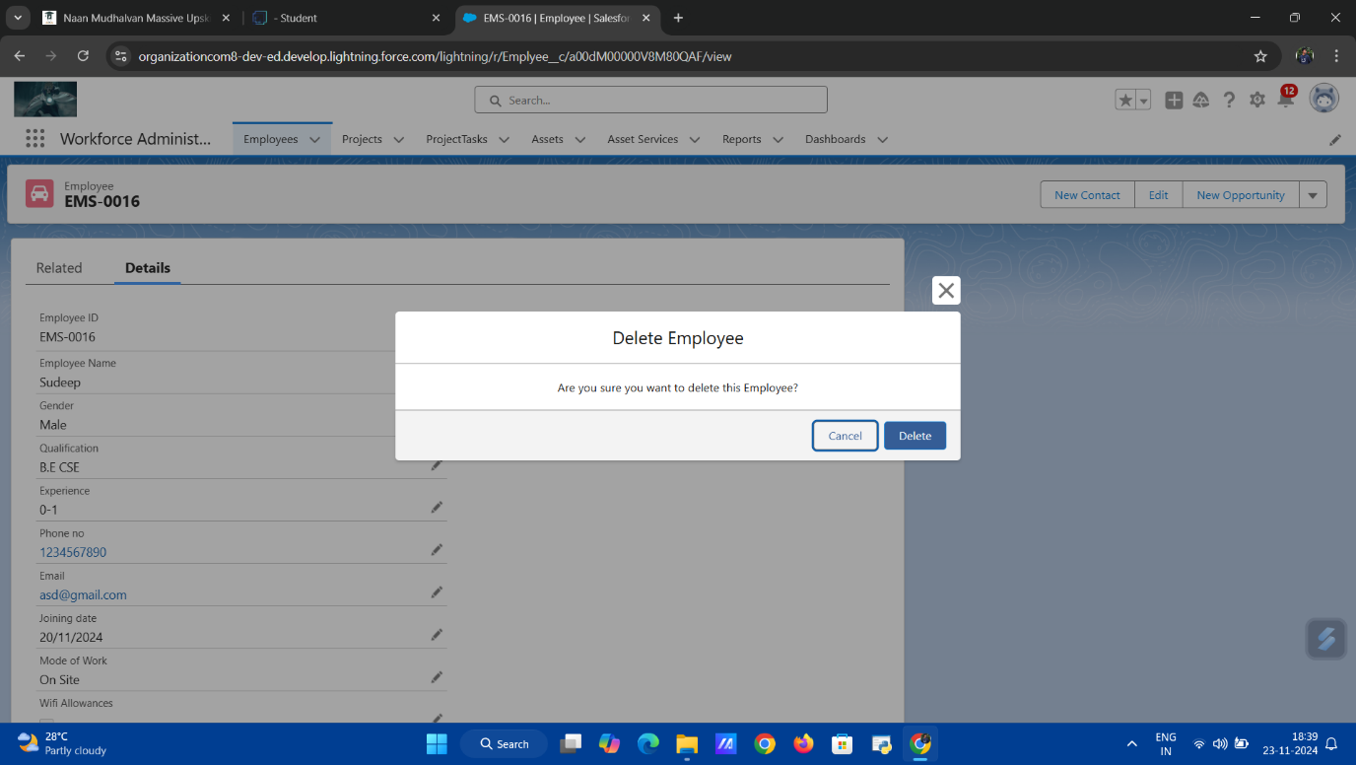

**Milestone 8: Import Data**

In the **Workforce Administration Solution (Dev)** project, importing data is a crucial step to populate the Salesforce environment with existing records. This ensures that historical and operational data is seamlessly integrated into the system, allowing users to leverage Salesforce's features for analysis and management.

**Activity 1: Importing Data Using Data Wizard**

The **Data Import Wizard** is used to import records into Salesforce quickly and efficiently. It is a user-friendly tool that supports importing data into standard and custom objects such as **Employee** and **Project**. Users can map data fields from an external file (e.g., CSV) to the corresponding Salesforce fields, ensuring accuracy and consistency during the import process.

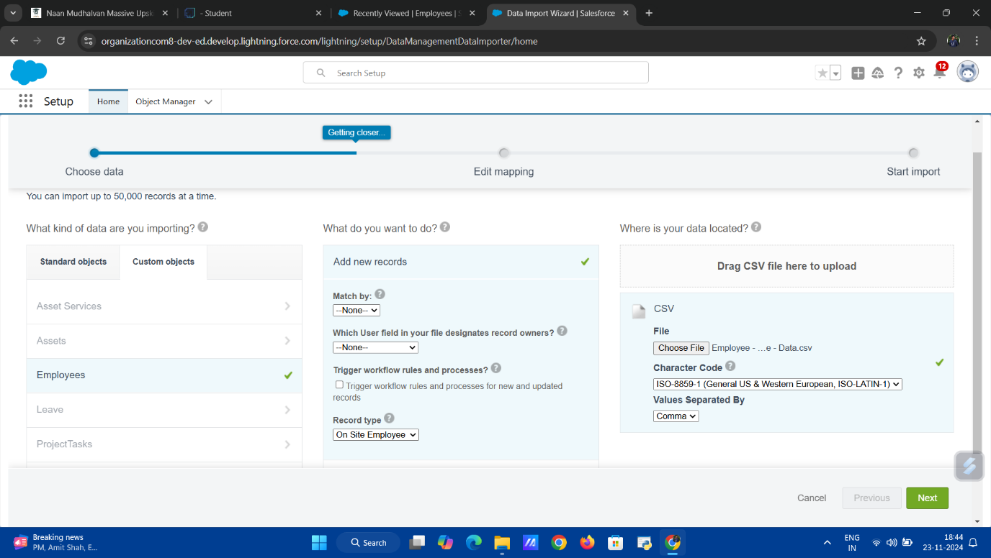

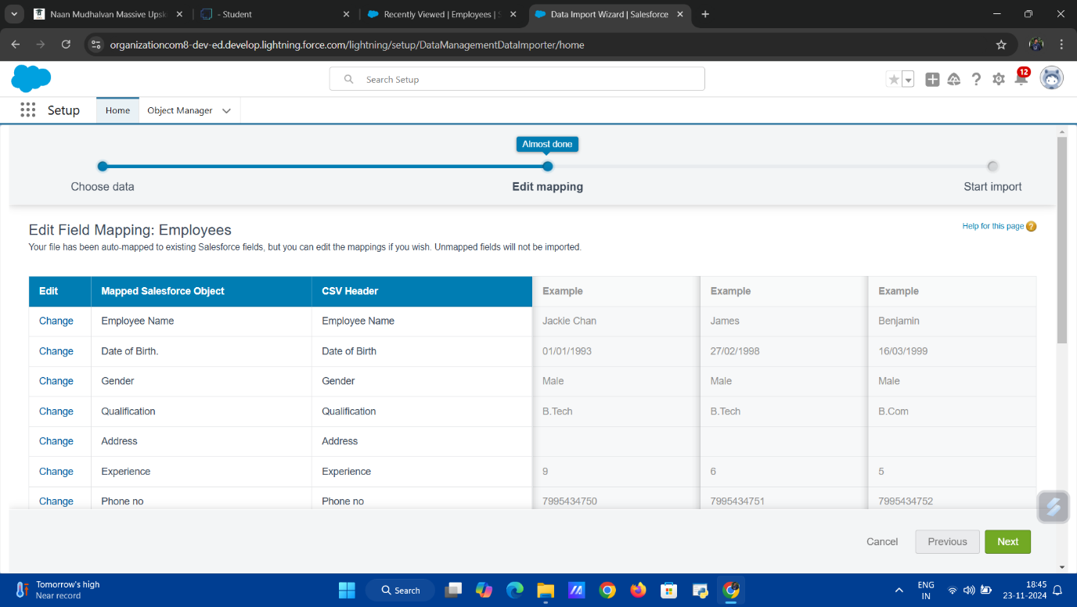

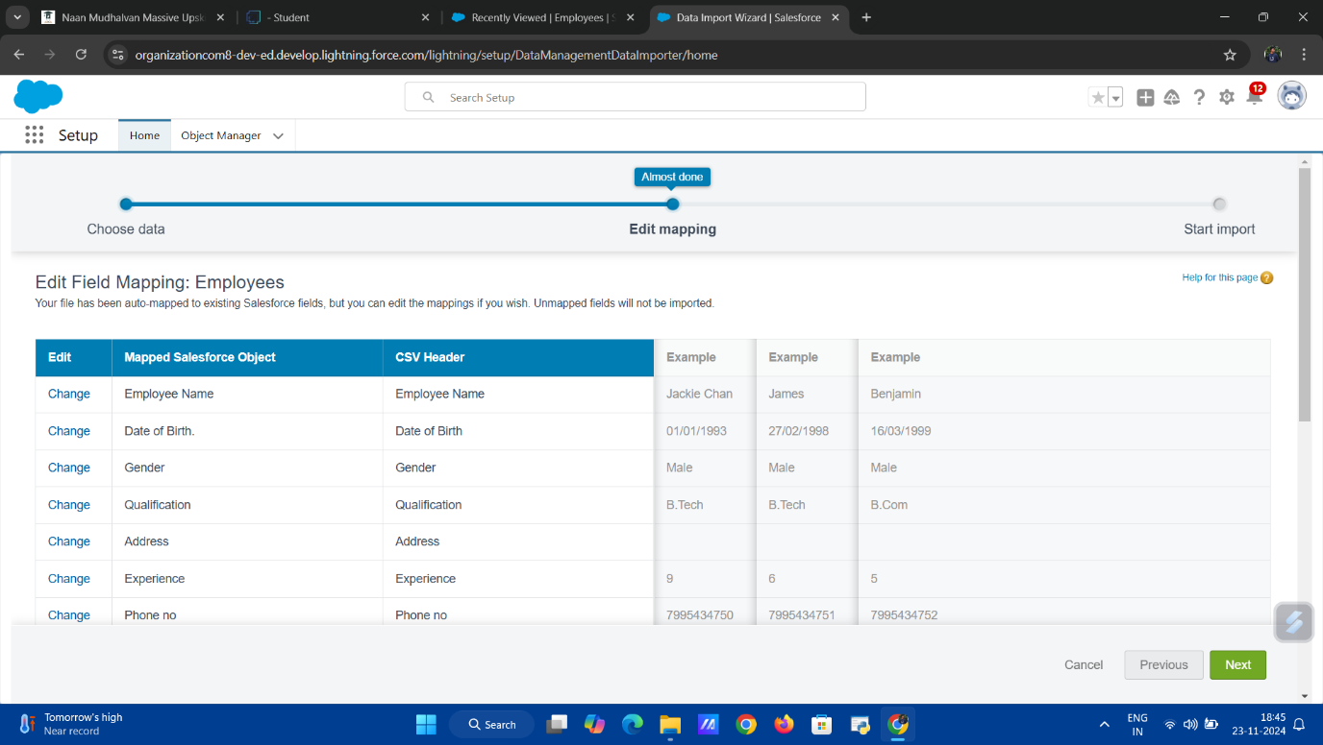

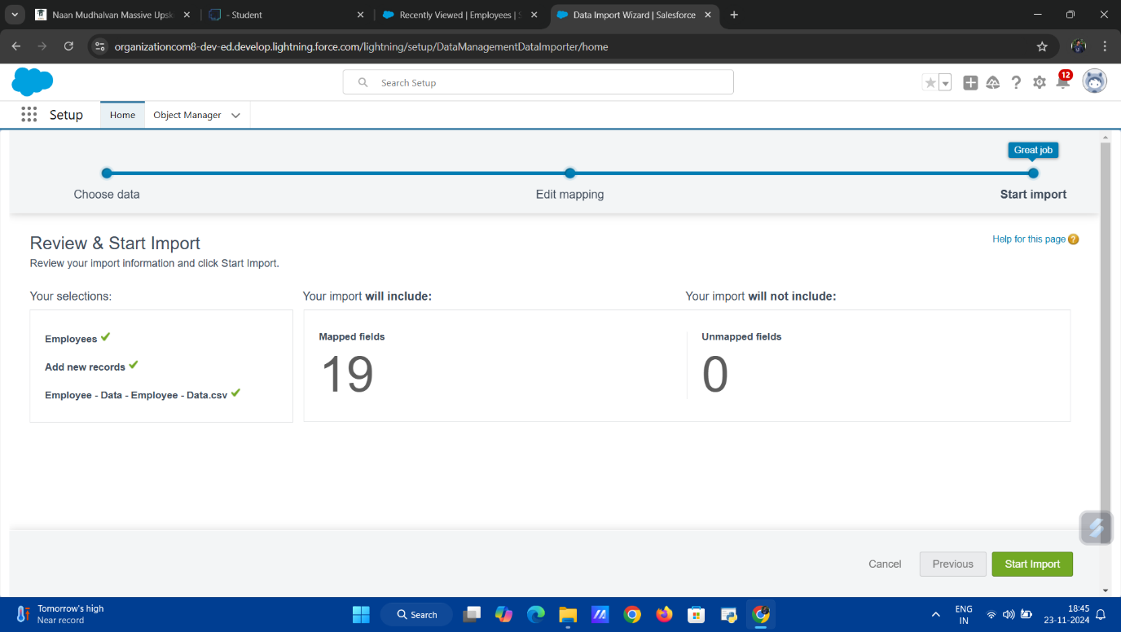

The activity involves uploading the file, selecting the object to import into, mapping fields, and running the import. Post-import, the system generates a summary report indicating the success of the operation and any errors encountered, allowing for corrections and re-imports if necessary.

**Milestone 9: Profiles**

In the **Workforce Administration Solution (Dev)** project, **Profiles** are a fundamental part of Salesforce's security model. They determine the level of access users have to objects, fields, and features within the system. This ensures that users can only interact with the data and tools relevant to their roles. The following activities involve creating specific profiles tailored to the roles within the organization.

**Activity 1: HR Profile**

The **HR Profile** is designed for Human Resources personnel, granting access to objects and fields required for managing employee data, such as the **Employee**, **Asset**, and **ProjectTask** objects. HR users are also provided permissions to create, edit, and delete employee records while having restricted access to sensitive project information.

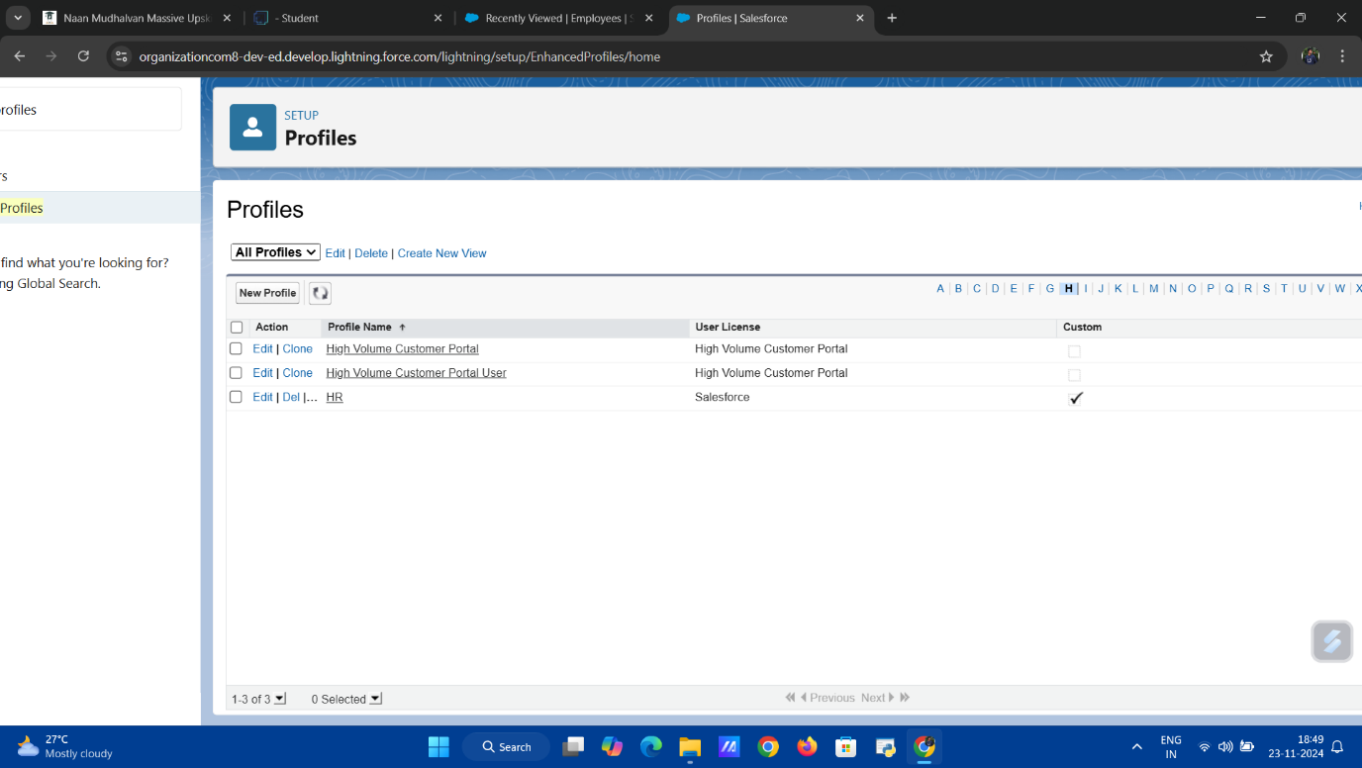

**Activity 2: Manager Profile**

The **Manager Profile** is tailored for project managers. It provides access to the **Project**, **Employee**, and **ProjectTask** objects, enabling managers to oversee project execution and team assignments. This profile includes permissions to view and edit project-related data but restricts access to HR-exclusive fields.

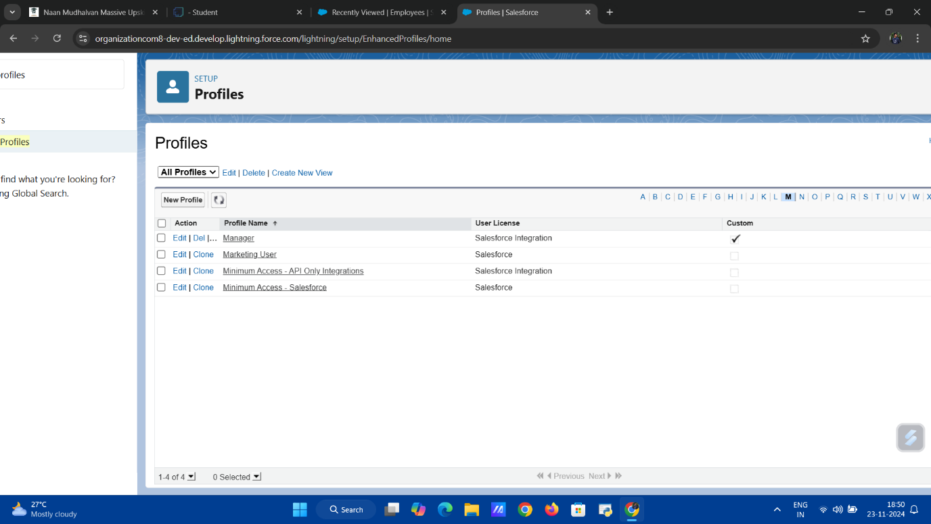

**Activity 3: Create Employee Profile**

The **Employee Profile** is created for general workforce users, granting limited access to objects such as **ProjectTask** and **Asset**. Employees can view their own records and assigned tasks while being restricted from viewing or modifying sensitive organizational data.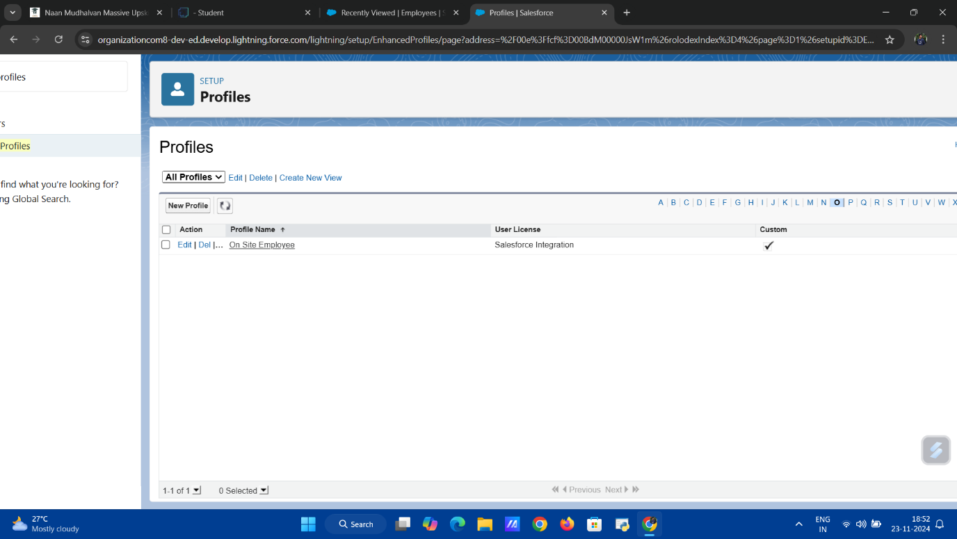

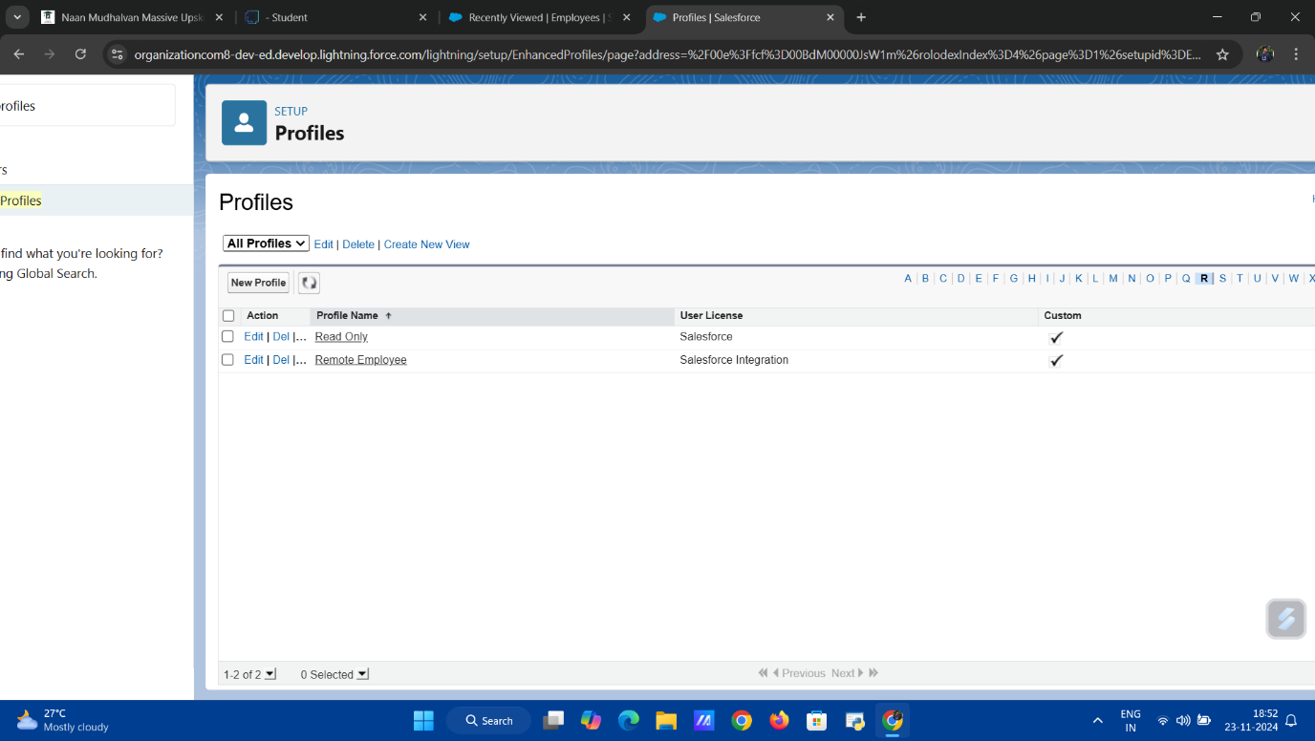

**Milestone 10: Role**

In the **Workforce Administration Solution (Dev)** project, **Roles** are a key element of the security and sharing model in Salesforce. Roles define the hierarchy within an organization and determine the level of access users have to records. By assigning roles, Salesforce administrators can control visibility of data at different levels of the organization, ensuring that users can only see records relevant to their responsibilities.

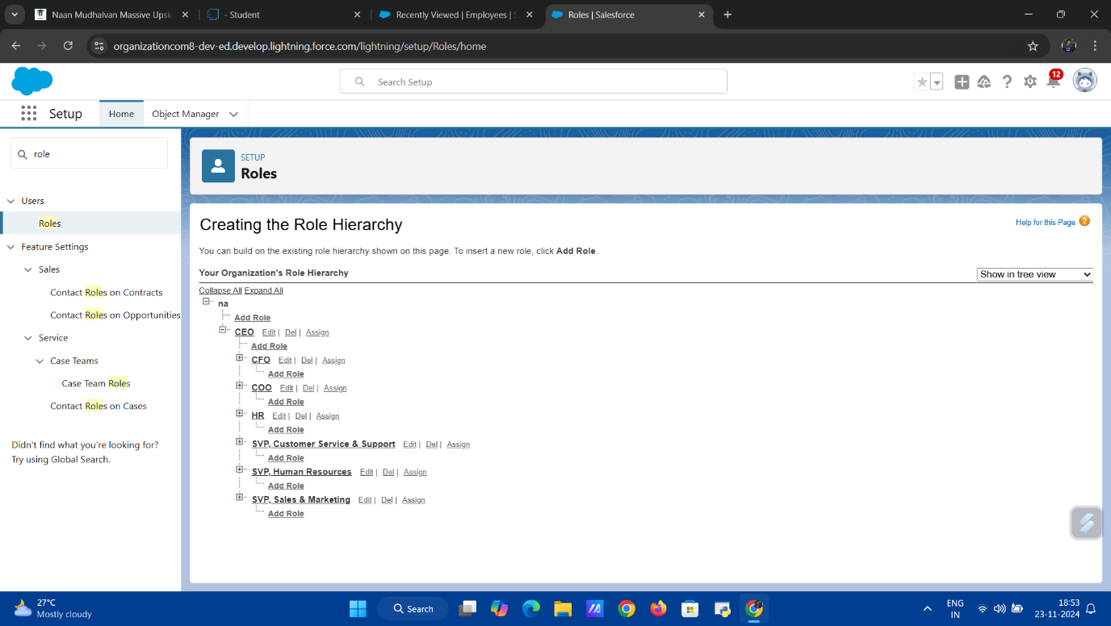

**Activity 1: Creating HR Role**

The **HR Role** is created to represent the Human Resources department within the organization. This role provides HR users with access to employee records and sensitive HR data. The HR role is typically placed higher in the role hierarchy to allow visibility and control over lower-level data while restricting access to project or asset-related information that doesn't concern HR personnel.

**Activity 2: Creating More Roles**

Additional roles are created for other departments or teams within the organization, such as **Manager**, **Employee**, or **Administrator**. Each role is designed to provide appropriate access levels to records, with higher roles having visibility over records owned by lower roles. These roles help organize users within the system and ensure that data visibility and security are maintained according to the organization’s structure.

**Milestone 11: Users**

In the **Workforce Administration Solution (Dev)** project, managing **Users** is a crucial task to ensure that the right individuals have access to the system with appropriate permissions. Users represent employees or team members who interact with the Salesforce platform and perform various actions based on their roles and profiles.

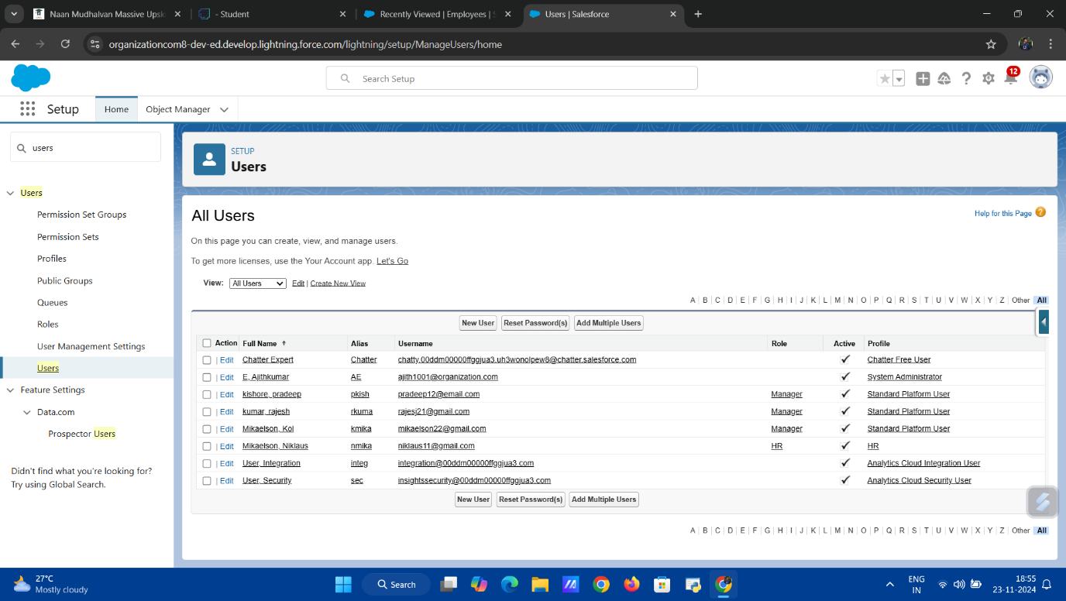

**Activity 1: Create User**

The first step in user management is creating a **User** within Salesforce. This involves providing essential details such as username, email, role, and profile. The newly created user is assigned appropriate permissions based on their job role (e.g., HR, Manager). This allows them to access relevant objects and data within the **Workforce Administration Solution (Dev)** project.

**Activity 2: Creating Another User**

Another user is created following the same process, but with a different role and profile to ensure that access is tailored to the user’s responsibilities. For example, a **Manager** user may be assigned a role with permissions to view and edit project data, while an **HR** user is granted access to employee records.

**Activity 3: Creating More Users**

Multiple additional users are created to represent other team members, each assigned to specific roles (such as **Employee**, **Project Manager**, or **Administrator**). By creating and managing these users, the system can accommodate a growing workforce, ensuring that each user has the necessary access based on their role within the organization.

**Milestone 12: Page Layouts**

In the **Workforce Administration Solution (Dev)** project, **Page Layouts** are essential for customizing the user interface and determining how information is displayed on a record page. Page layouts control the organization and visibility of fields, buttons, and related lists, allowing users to efficiently interact with records in Salesforce. Customizing page layouts ensures that relevant information is easily accessible to different users.

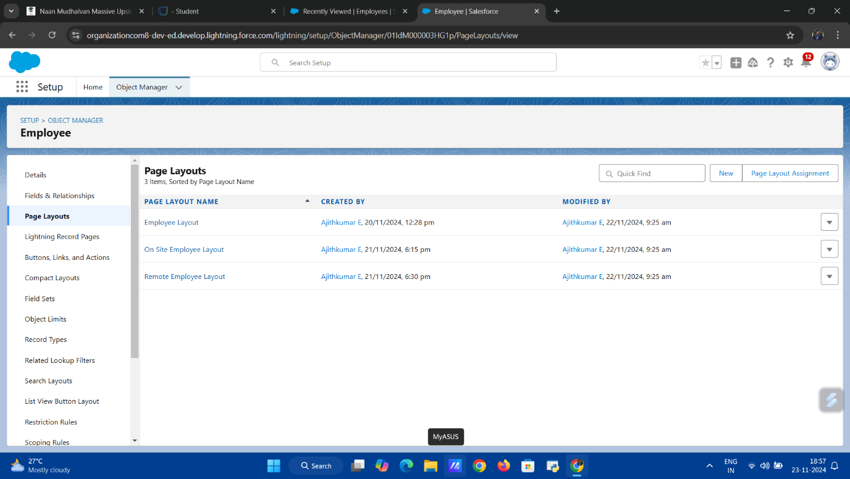

**Activity 1: Creating a Page Layout for Employee Object**

A **Page Layout** for the **Employee** object is created to determine how employee records will be displayed and organized in Salesforce. This layout includes key fields such as **Name**, **Job Role**, **Department**, and **Date of Birth**, as well as related lists for **Asset** and **Project**. The layout is designed to ensure HR personnel can easily view and edit employee information. Additional features such as sectioned areas and quick action buttons are added to streamline the user experience.

**Activity 2: Creating Another Page Layout**

An additional page layout is created for another user group or role, such as **Managers**. This layout may display a different set of fields and related lists, relevant to a manager’s responsibilities, such as **Project Assignments**, **Employee Performance**, or **Task Status**. The layout is tailored to ensure that managers can access and interact with data that supports their decision-making processes, while ensuring that sensitive HR information is kept hidden from them.

**Milestone 13: Chatter Group**

In the **Workforce Administration Solution (Dev)** project, **Chatter Groups** are an essential tool for enhancing collaboration and communication among users within Salesforce. Chatter provides a social network-like experience, allowing users to share updates, discuss tasks, and collaborate on projects in real-time. Creating a Chatter Group helps centralize communication for specific teams or topics, making it easier to track conversations and updates.

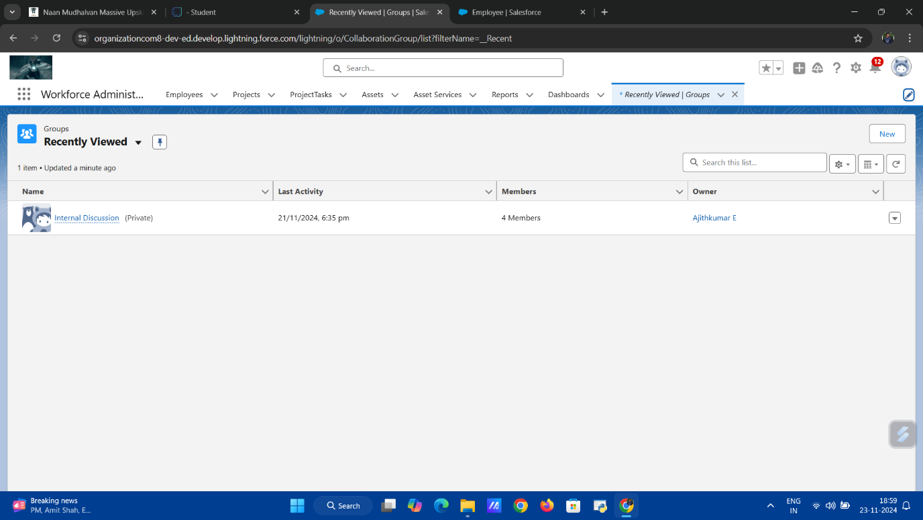

**Activity 1: Creating a Chatter Group for Your Organization**

A **Chatter Group** is created to facilitate communication within the organization. This group serves as a central hub for discussing workforce-related matters, such as project updates, employee performance, and asset management. The group is configured to include relevant members, such as HR personnel, managers, and project leads, depending on the focus of the group.

The Chatter group is set up with privacy settings, allowing for either public or private discussions, based on the organization's needs. Users can post updates, share files, and ask questions, ensuring seamless communication and collaboration within the **Workforce Administration Solution (Dev)** project.

**Milestone 14: Record Types**

In the **Workforce Administration Solution (Dev)** project, **Record Types** allow for the customization of records within Salesforce, enabling different business processes for different types of records. Record types are useful for managing data that needs to be categorized based on user roles or specific needs, such as distinguishing between **On-site Employees** and **Remote Employees** in the system.

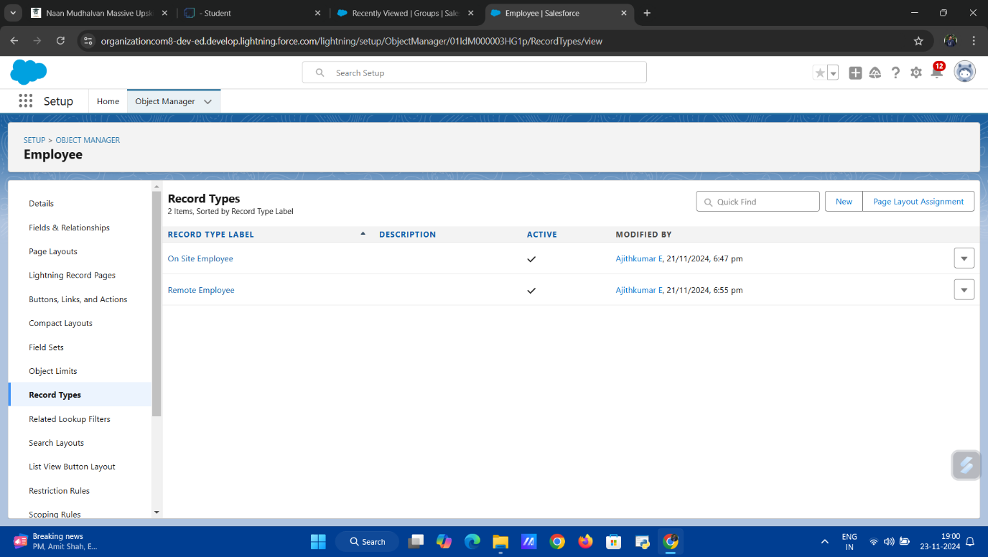

**Activity 1: Creating On-Site Employee Record Type**

The **On-Site Employee** record type is created to categorize employees who work at physical office locations or client sites. This record type is configured with specific page layouts and picklist values tailored for on-site employees, such as office location, department, and work schedules. By creating this record type, HR and managers can easily differentiate between on-site and remote employees and streamline their management processes.

**Activity 2: Creating "Remote Employee" Record Type**

The **Remote Employee** record type is created for employees who work from home or outside the physical office. This record type includes different page layouts, fields, and picklist values relevant to remote workers, such as home office location, remote work tools, and communication preferences. It allows for the tracking and management of remote employees in a way that reflects their unique work environment.

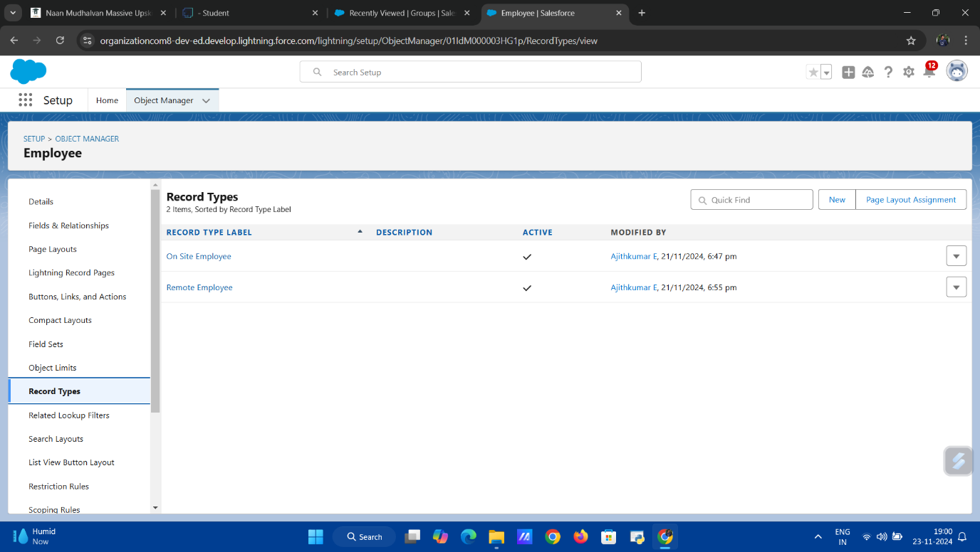

**Milestone 15: Permission Sets**

In the **Workforce Administration Solution (Dev)** project, **Permission Sets** are used to grant additional permissions to users, beyond what is provided by their profile. This enables administrators to tailor access to specific objects, fields, or actions without changing a user’s profile. Permission sets are a powerful way to manage granular security and permissions for different users across various roles within the system.

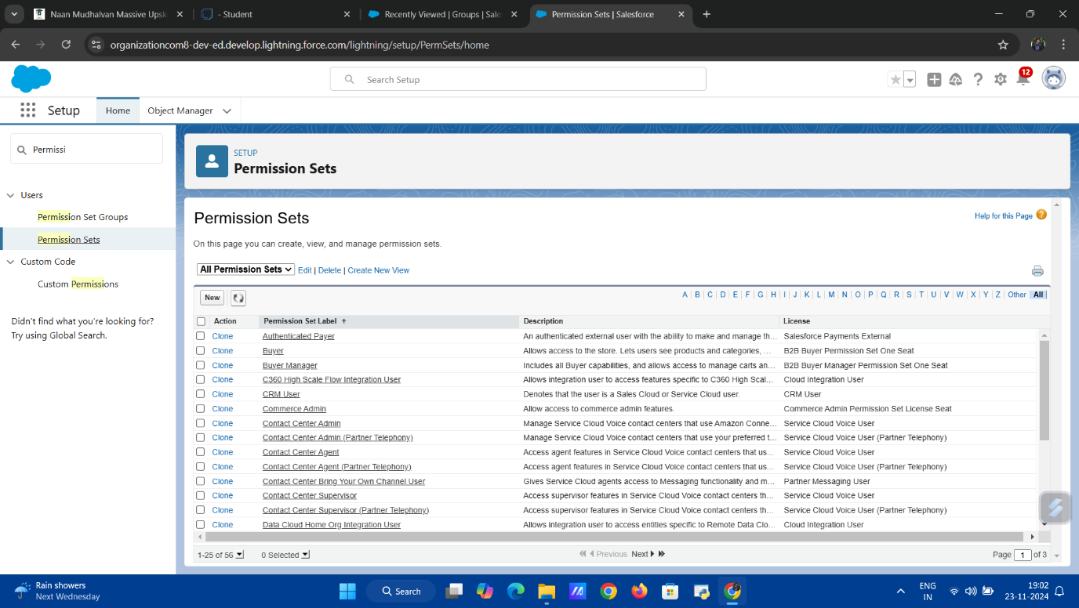

**Activity 1: Creating a Permission Set**

A **Permission Set** is created to assign specific permissions to users based on their needs. In this activity, a new permission set is created to provide additional access to certain users. For example, a permission set may be created to allow **HR** users to view or edit fields related to employee details, or to grant **Managers** access to project task information that isn’t typically available under their standard profile.

The permission set is configured by selecting the permissions and object-level access that are necessary for the users’ roles. Once created, the permission set is assigned to the appropriate users, ensuring they have the necessary access to perform their tasks without compromising data security.

**Milestone 16: Reports**

In the **Workforce Administration Solution (Dev)** project, **Reports** are a powerful tool for analyzing and summarizing data stored within Salesforce. Reports allow users to generate insights from various records, such as **Employee**, **Project**, and **Asset** data, by presenting them in a structured format. These reports can be customized to meet specific business needs, allowing users to filter, group, and display data in ways that facilitate decision-making and performance tracking.

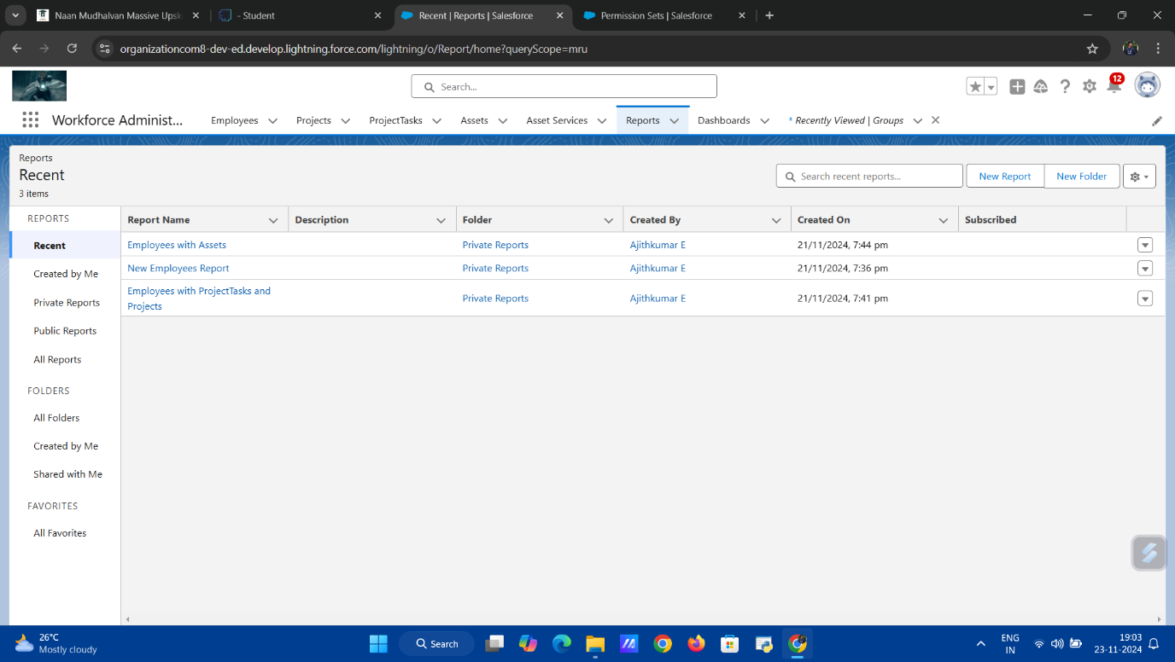

**Activity 1: Create Report**

In the first activity, a **Report** is created to extract and display data related to a specific aspect of the project. For example, a report can be created to show a list of **Employees** with their project assignments or a summary of **Asset** usage across different departments. The report is created using the Salesforce **Report Builder**, where users can choose from various formats like tabular, summary, or matrix reports, and apply filters to display only the relevant data. Fields can be grouped, summarized, and calculated to generate meaningful insights, such as the number of active employees or the total value of assets in use.

**Activity 2: Create 2 More Reports**

In this activity, two additional reports are created to provide a broader view of the project’s performance and operations. For example, one report could focus on tracking **Project** progress by showing milestones, task completion, and deadlines. The second report might summarize **Asset Service** records to display upcoming maintenance schedules or asset utilization rates. Each report is designed to address different business needs, allowing stakeholders to monitor different aspects of the project.

By utilizing **Reports**, the **Workforce Administration Solution (Dev)** project enables users to track key metrics, analyze trends, and make data-driven decisions to improve operations and outcomes.

**Milestone 17: Dashboards**

In the **Workforce Administration Solution (Dev)** project, **Dashboards** provide visual representations of key performance indicators (KPIs), metrics, and other important data in real-time. Dashboards allow users to gain quick insights into various aspects of the project, such as employee performance, project progress, and asset management. By displaying data in a visually appealing and easy-to-understand format, dashboards help decision-makers make informed choices.

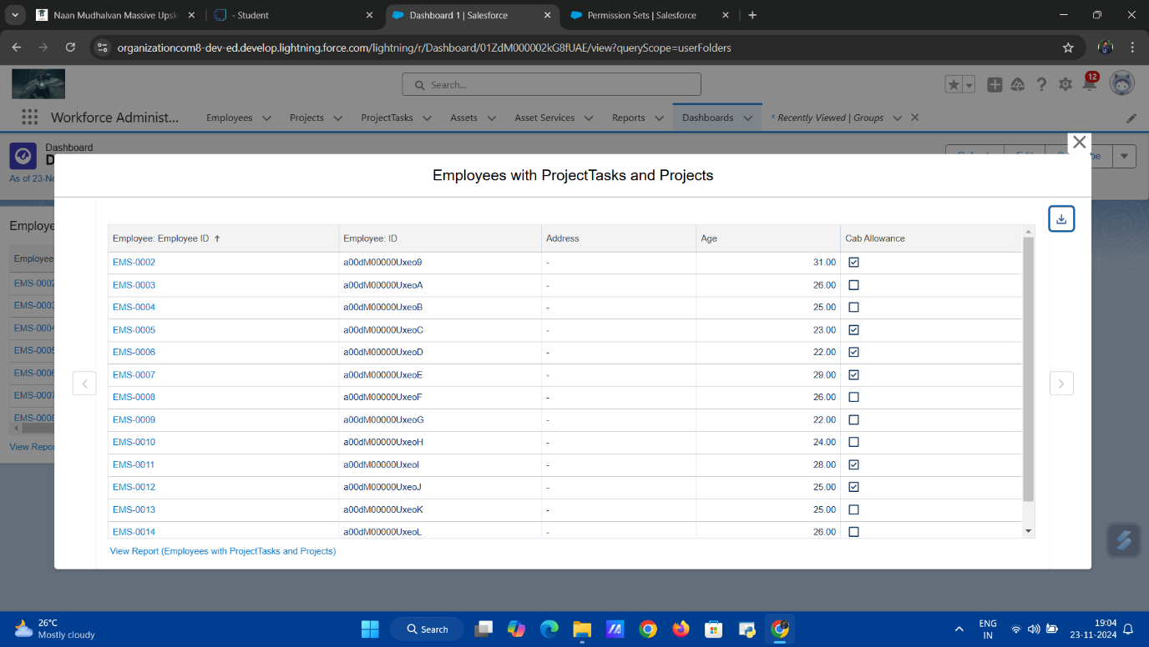

**Activity 1: Create Dashboard**

A **Dashboard** is created to display important data related to the **Workforce Administration Solution (Dev)** project. For example, a dashboard can be created to track employee performance, project completion status, or HR metrics. The dashboard is configured by adding various **report charts** and data visualizations that reflect key metrics like the number of active employees, project milestones, and asset utilization. Filters can be applied to tailor the dashboard for specific user needs, such as viewing data for a particular department or time period.

**Activity 2: Create Another Dashboard**

A second **Dashboard** is created, following similar steps as Activity 1, but with a different focus. For example, this dashboard could focus on tracking **asset management** and **task completion** across different projects. It may include charts showing the number of assets assigned to employees, the status of tasks assigned, or the overall resource

availability. Just like the first dashboard, this one is also customizable, with visual elements that highlight the most critical data for project managers, HR, or asset managers.

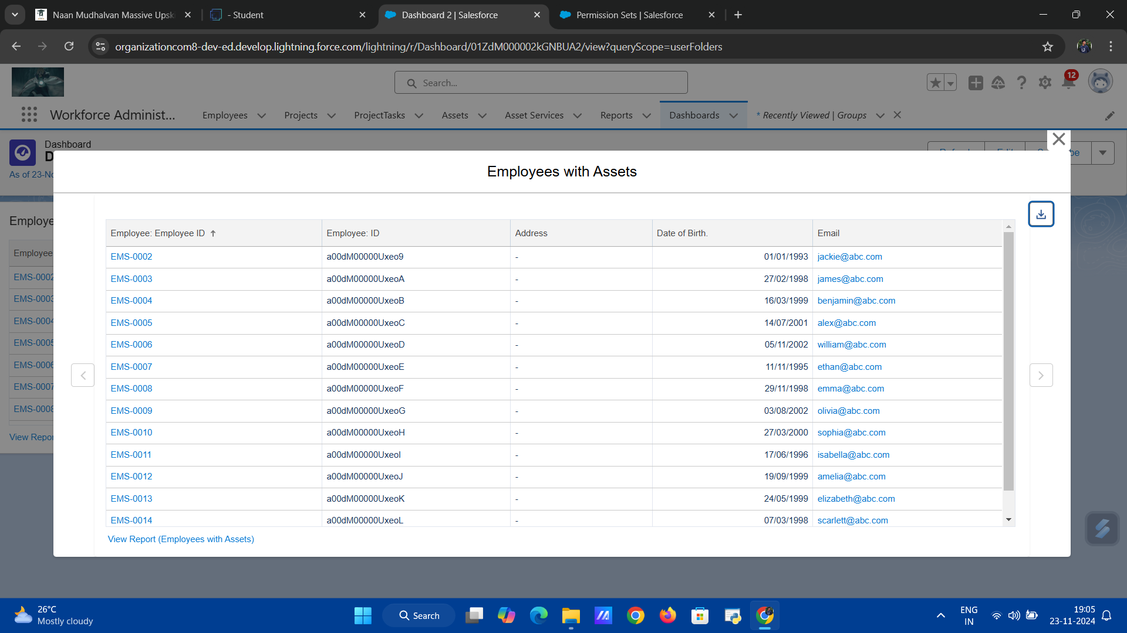

**Milestone 18: Approval Process**

In the **Workforce Administration Solution (Dev)** project, the **Approval Process** is a streamlined, automated workflow used to manage record approvals within Salesforce. It ensures that specific records, such as **employee leave requests** or **asset requests**, undergo a formal review and approval process before being finalized. The approval process improves consistency, transparency, and efficiency by setting clear steps for review and approval.

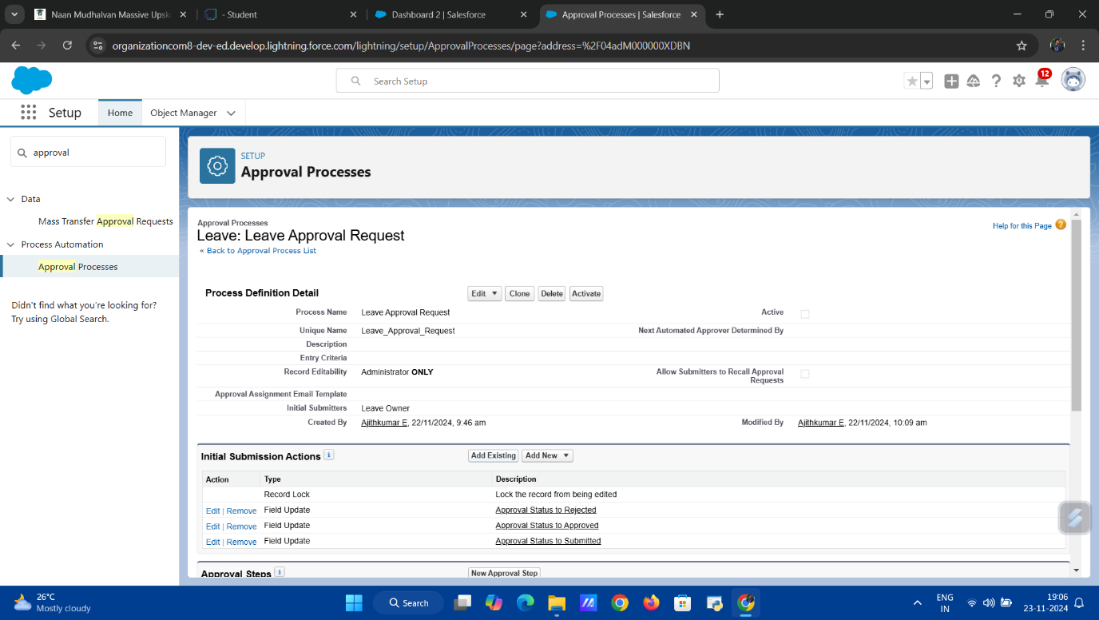

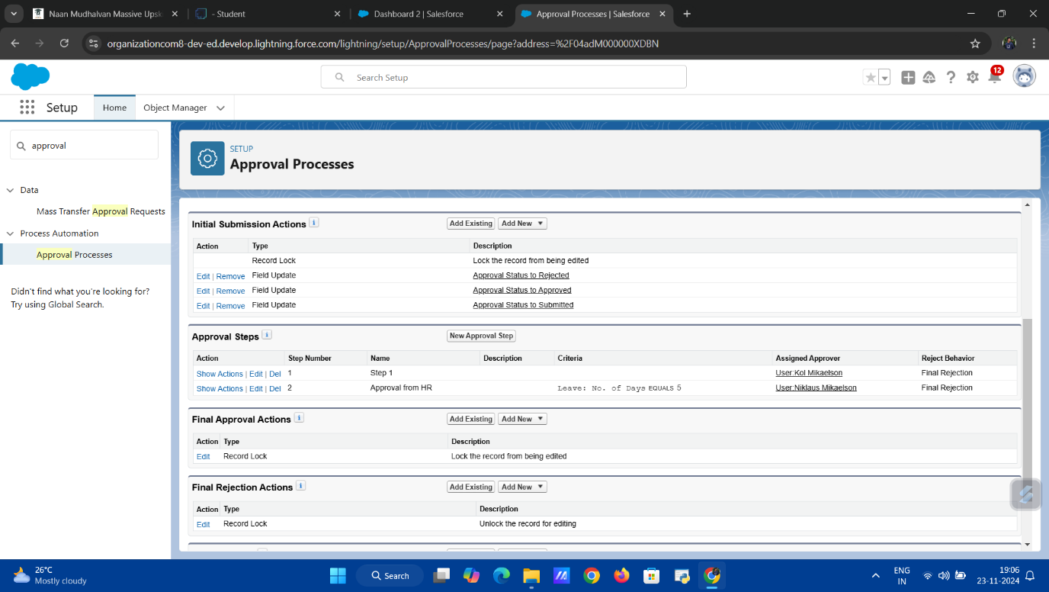

**Milestone 19: Apex Trigger**

In the **Workforce Administration Solution (Dev)** project, **Apex Triggers** are used to automate and customize Salesforce functionality by executing actions based on changes to Salesforce records. Triggers are essential for handling business logic that cannot be achieved with standard workflows or process automation. They allow for the automation of operations like data validation, record updates, and complex calculations when records are created, updated, or deleted.

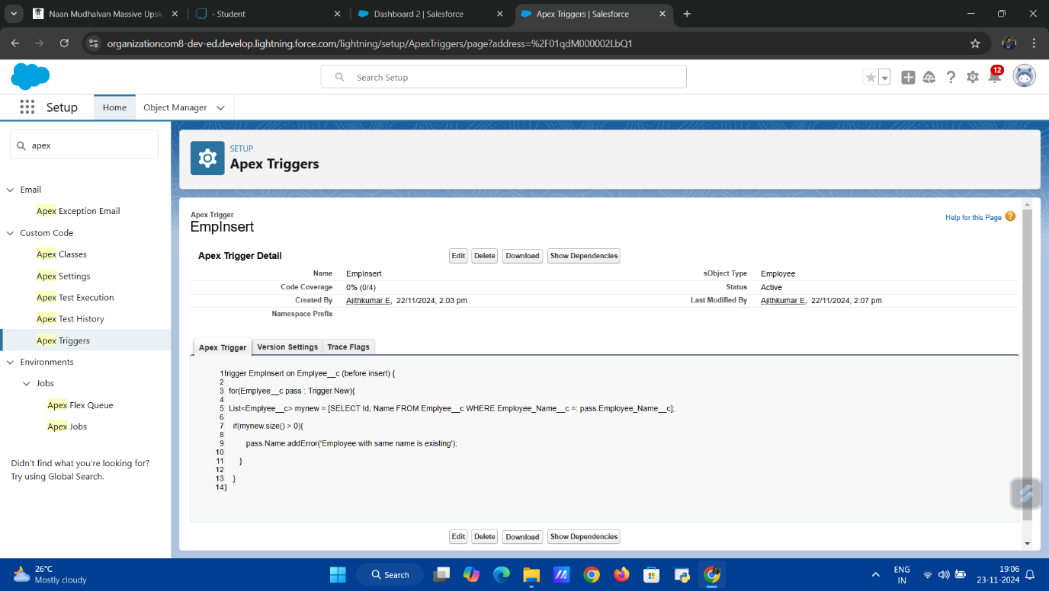

**Activity 1: Create an Apex Trigger**

An **Apex Trigger** is created to automate specific actions within the **Workforce Administration Solution (Dev)** project. For example, a trigger can be set up to automatically update an **Employee** record whenever a related **Asset** record is modified. In this activity, the Apex trigger is written using Apex programming language, defining the operations to be executed when certain conditions are met, such as creating or updating a record.

The trigger is created with a specific event (e.g., after insert, before update, etc.) and the required logic to achieve the desired outcome, such as updating related fields, creating child records, or sending notifications. This ensures that data integrity is maintained and specific actions are performed automatically when records are modified.

**Activity 2: Testing the Trigger**

After the **Apex Trigger** is created, it is important to test it to ensure that it functions correctly. In this activity, unit tests are written to verify that the trigger behaves as expected. Testing ensures that the trigger performs its intended actions (such as updating fields, sending notifications, or creating related records) without causing errors or unexpected behaviors.

Salesforce requires that triggers be tested thoroughly, and tests are executed in a controlled environment to check for edge cases, such as when no records are affected or when records meet certain criteria. Once the tests pass successfully, the trigger is deployed to production.